UC Berkeley’s top-ranked College of Environmental Design is offering a suite of dynamic summer programs incorporating architecture in all its forms, designed for participants of all ages and backgrounds.

Summer [IN]STITUTE: [IN]ARCH ADV
[link to: https://ced.berkeley.edu/academics/summer-programs/summer-institute/inarch-adv/]
July 2-August 10
College Seniors and Post-Baccalaureates
Experience in Architecture Required
International Application Deadline: Friday, May 11
Domestic Application Deadline: Tuesday, May 15

[IN]ARCH ADV participants come from architecture programs across the globe to spend six weeks on the Berkeley campus strengthening their design portfolios, experimenting in the digital fabrication shop, connecting to faculty and practitioners, advancing their conceptual ideas, building an international network of like-minded peers, and learning to see their work, their practice and their world in clearer focus.

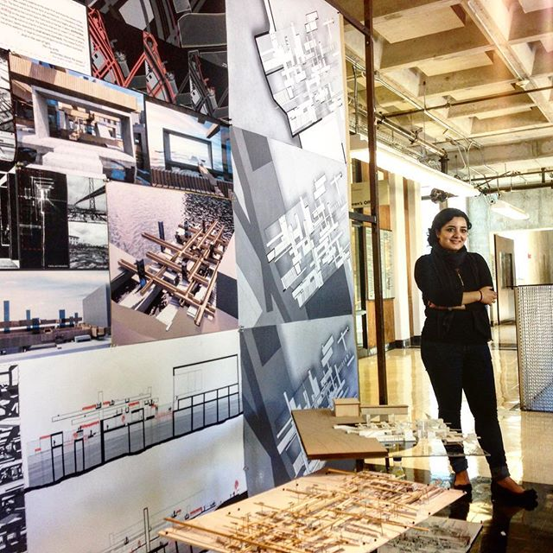

Disc* (Design & Innovation for Sustainable Cities)
[link to: https://ced.berkeley.edu/academics/summer-programs/discovery/]
July 2-August 3
Currently Enrolled College Students
Architecture Experience Welcome but not required
International Application Deadline: Friday, May 11
Domestic Application Deadline: Tuesday, May 15

Disc is an intensive five week summer program that takes an interdisciplinary and multi-scalar approach to design and analysis in the urban environment, incorporating elements of architecture, landscape architecture, digital fabrication, urban design and city planning into its curriculum. Disc* participants engage in the discourses of urban innovation, acquiring the tools and expertise necessary to craft design-based solutions that meet the increasingly urgent challenges of global urbanization.

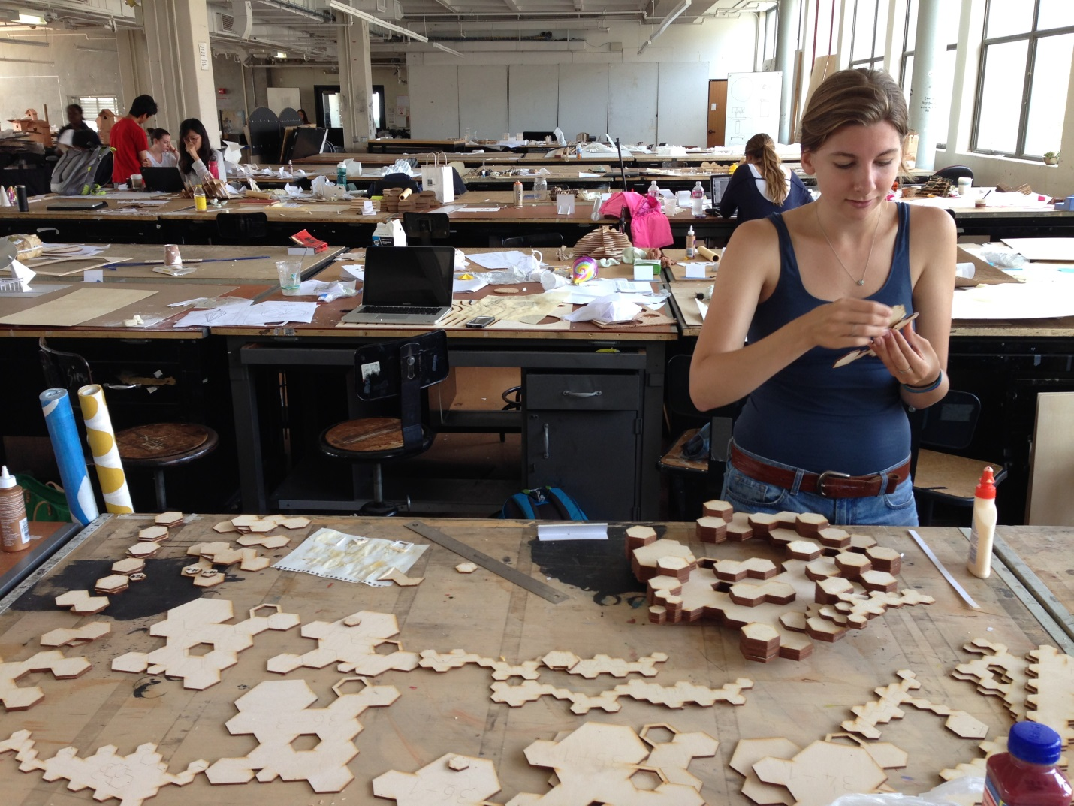

Summer [IN]STITUTE: [IN]ARCH
[link to: https://ced.berkeley.edu/academics/summer-programs/summer-institute/inarch/]
July 2-August 10
College Seniors and Post-Baccalaureates
No Architecture Experience Required
International Application Deadline: Friday, May 11
Domestic Application Deadline: Tuesday, May 15

[IN]ARCH is an intensive program designed to immerse students in the foundational theories and practices of architectural design. The program is structured as an introduction to studio culture and architectural discourse, and serves as a vehicle for further academic pursuits in the field. Most [IN]ARCH participants find themselves making, representing, discussing and thinking in ways unfamiliar to them, and they encounter faculty enthusiastic about introducing new students to this demanding and rewarding field.

Photo Credit: Julie Turgeon

embARC Summer Design Academy
[link to: https://ced.berkeley.edu/academics/summer-programs/embarc-design-academy/]
July 2-27
High School Students
No Architecture Experience Required
International Application Deadline: Friday, April 20
Domestic Application Deadline: Monday, April 30

embARC brings together high school students from diverse backgrounds to explore architecture, urban design and sustainable city planning through integrated components: an Architecture + Urban Design Studio, a Sustainable Planning Workshop, a Digital Design Workshop, an Environmental Design Conversations Series, and a Community Build Project.
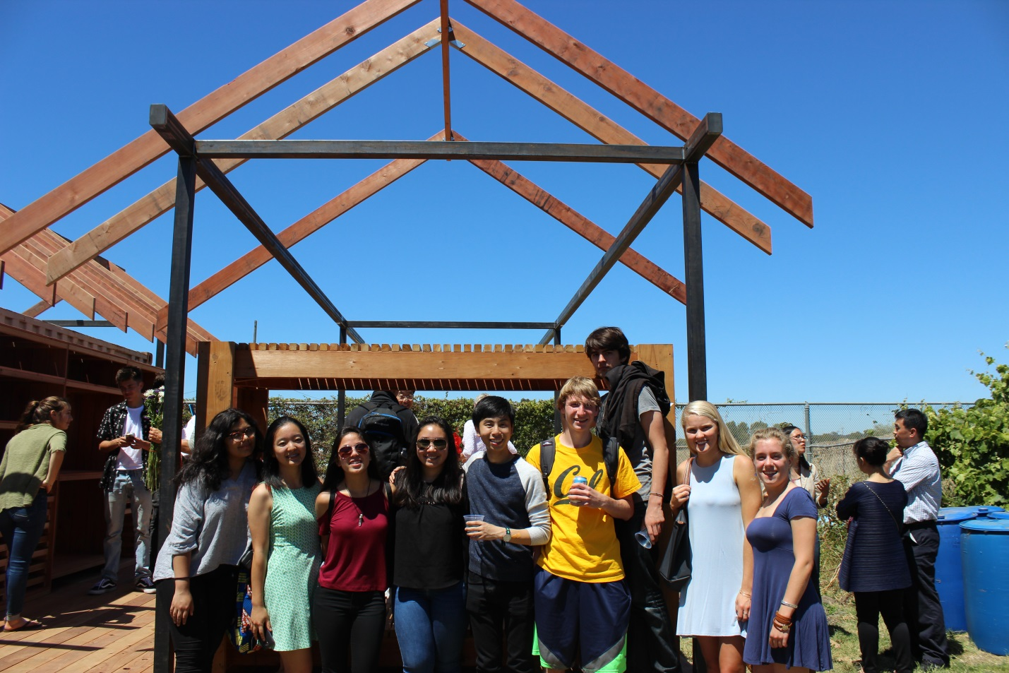

Summer [IN]STITUTE: [IN]LAND
[link to: https://ced.berkeley.edu/academics/summer-programs/summer-institute/inland/]
July 2-August 10
College Seniors and Post-Baccalaureates
No Architecture Experience Required
International Application Deadline: Friday, May 11
Domestic Application Deadline: Tuesday, May 15

The [IN]LAND program introduces participants to the practice of landscape architecture as an active inquiry. Students will be introduced to the fundamentals of landscape architectural practice through the process of making and experimentation as research into site potentials. Initial ideas will be developed and transformed through rigorous investigation in a collaborative studio environment. Students will develop a landscape vocabulary that engages with the concepts of ecology, public space, sustainability and multiple scales of design.
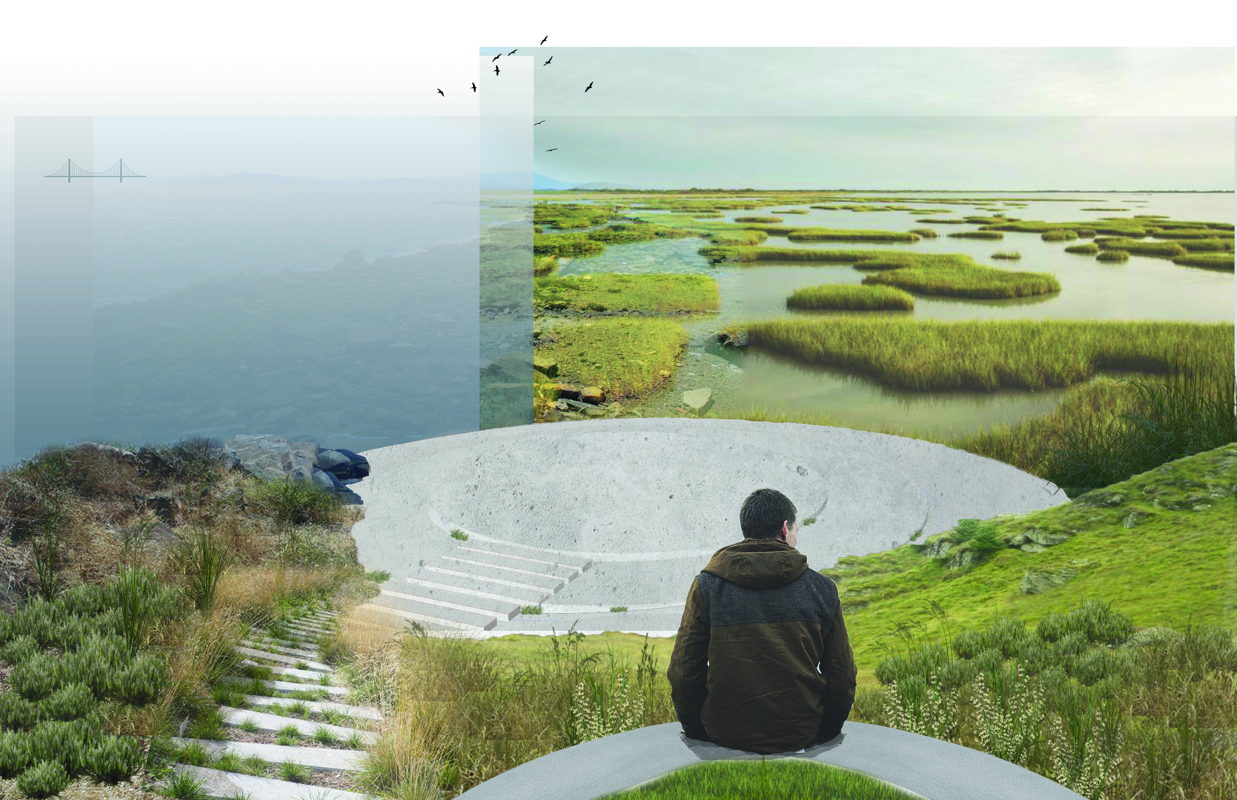
Photo Credit: Alice An
Apply now! cedberkeley.slideroom.com
Learn more about CED Summer Programs!
[link to: https://ced.berkeley.edu/academics/summer-programs/]
